SYSTEMS ANALYSIS AND MODELLING

10 - AMALIY ISH
NYQUIST DIAGRAMMASINI ANIQLASH
2-tartibli tizim uchun Nyquist tahlili

Bajardi: Bozorqulov Sardor
Guruh: ISEE-01U

Topshiriq: G(s) = (s+8) / [s(s+3)(s+6)]
G(s) = (s+8) / [s*(s+3)*(s+6)]

Nazariy Tahlil
Maxrajni kengaytirish:

(s+3)*(s+6) = s^2 + 9s + 18
s*(s^2+9s+18) = s^3 + 9s^2 + 18s

Surat: (s+8) => num = [1, 8]
Maxraj: s^3+9s^2+18s => den = [1, 9, 18, 0]

Nol (zero) | s = -8
Qutb 1 (pole) | s = 0 (integrator — Type '1')
Qutb 2 (pole) | s = -3
Qutb 3 (pole) | s = -6
Tizim turi | Type '1' (bitta s=0 qutb)
P qiymati | P = 0 (barcha qutblar chap yarim tekislikda, s=0 hisoblanmaydi)

MATLAB Kodi
clc
clear

% Surat: (s+8)
num = [1 8]

% Maxraj: s*(s+3)*(s+6) = s^3 + 9s^2 + 18s
den = conv([1 0], conv([1 3], [1 6]))

g = tf(num, den)

nyquist(g)
title('Nyquist Diagram: G(s) = (s+8)/[s(s+3)(s+6)]')
grid on

Terminal Natijasi
num =
1 8

den =
1 9 18 0

Transfer function 'g':
s + 8
-----------------
s^3 + 9s^2 + 18s

Nyquist Diagrammasi Grafigi
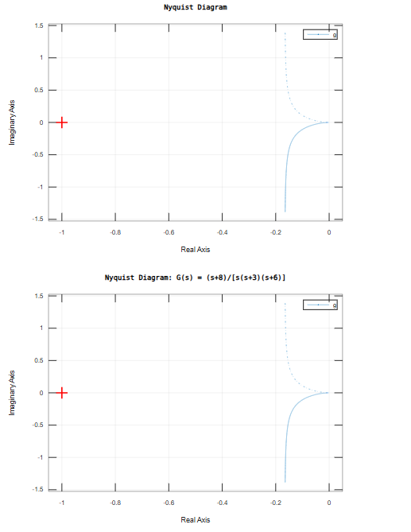

Savollarga Javoblar
1. Nyquist Contour (Kontur) nima?
Nyquist konturi — s-tekislikdagi maxsus yopiq egri chiziq bo'lib, u kompleks tekislikning butun o'ng yarim qismini (barqarorsiz hududni) o'rab oladi.

Kontur qismlari | 1) Imaginär o'q bo'ylab (-j∞ dan +j∞ gacha)
 | 2) Cheksiz radiusli yarim doira (o'ng tomonda)
Maqsadi | Barqarorsiz qutblar mavjudligini tekshirish
Cauchy prinsipi | Kontur ichidagi nollar va qutblar sonini aniqlaydi
Nyquist mezoni | N = Z - P tenglamasini yechish imkonini beradi

Nyquist konturi orqali G(jw) funksiyasini w = -∞ dan +∞ gacha o'zgartirib, kompleks tekislikdagi egri chiziq hosil qilinadi. Agar bu egri chiziq (-1+j0) nuqtasini o'rab olsa, tizim beqaror.

2. Polar Diagramma nima? Nyquist diagrammasidan farqi?
Polar diagramma — G(jw) funksiyasining w = 0 dan +∞ gacha bo'lgan qiymatlarini kompleks tekislikda tasvirlash. Har bir nuqta amplituda va fazani ifodalaydi.

Xususiyat | Polar Diagramma | Nyquist Diagramma
Chastota diapazoni | w: 0 dan +∞ gacha | w: -∞ dan +∞ gacha
Ko'rinish | Yarim egri chiziq | To'liq egri chiziq (simmetrik)
Simmetriya | Yo'q | Real o'qqa nisbatan simmetrik
Barqarorlik | To'liq mezon bermaydi | To'liq Nyquist mezoni
Murakkablik | Oddiyroq | Murakkabroq, ammo to'liq
Foydalanish | Dastlabki tahlil | Barqarorlikni tekshirish

Qisqa xulosa: Polar diagramma Nyquist diagrammasining faqat yuqori qismi (w > 0). Nyquist diagrammasi esa to'liq — ham musbat, ham manfiy chastotalar uchun. Barqarorlikni aniq tekshirish uchun Nyquist diagrammasi ishlatiladi.

